**MID-ATLANTIC BIOSAFETY ASSOCIATION**

## 34th ANNUAL BIOSAFETY SYMPOSIUM

## Thursday, June 16, 2022

**The Center for Discovery and Innovation (CDI)**

**111 Ideation Way, Nutley, NJ 07110**

**Register for the Symposium at** [**www.mabsa.org**](http://www.mabsa.org)

**Members $50.00 in person/$25.00 virtual**

**Non-Members $70.00 in person/$35 virtual**

**Students $20.00 in person/$10.00 virtual**

|  |  |  |
| --- | --- | --- |
| **Time** | **Presentation Title** | **Speaker** |
| 7:30 am – 8:00 am | Registration and Breakfast - Visit the Exhibitors | |
| 8:00 am -8:10 am | Welcome and Introductions | Su Hung-Cunliffe  Symposium Chair |
| 8:10 am- 8:30 am | ABSA update | Melissa Morland, RBP, CBSP  ABSA Past President |
| Moderator: Amy Ryan, MABSA President | | |
| 8:30 am – 9:20 am | Translating Biosafety in the Clinical Realm | Sean Fitzgerald, MPH, RBP  Manager of Biological Safety and Environmental Health and Safety, The Center for Discovery and Innovation (CDI) |
| 9:20 am -10:10 am | Large Scale Viral Vector Production- Engineering Controls verse Respiratory Protection-What Makes Sense? | Brian Petuch, RBP, CBSP, Biosafety Project Manager, International Safety Systems |
| 10:10 am -10:30 am | Morning Break and Visit Exhibitors | |
| Moderator: Su Hung-Cunliffe, MABSA President Elect | | |
| 10:30 am – 11:20 am | Genes Out and Virus In | Dianne Langford, PhD, CBSP, Associate Dean for Research, Professor Neural Sciences, Lewis Katz School of Medicine, Temple University |
| 11:20 am -12:10 pm | Strategies employed at the University of Virginia to optimize IBC and Biosafety (EHS) partnership | Thomas Leonard, PhD, CBSP, EHS Director, UVA Responsible Official for Select Agents, University of Virginia. |
| 12:10 pm -1:30 pm  12:55 pm - 1:25 pm | Lunch and Visit Exhibitors   * Rolling Facility Tour – Meet at Exhibitor’s Hall (8/10 people per group) * MABSA Business Meeting | |
| Moderator: Laura Newton, MABSA Councilor | | |
| 1:30 pm - 2:20 pm | Dangerous Goods shipping at academic institutions | Marie-Luise Faber, Assistant Biosafety Officer, Environmental Health & Radiation Safety  University of Pennsylvania |
| 2:20 pm – 2:40 pm | Afternoon Break - Final Visit to Exhibitors | |
| Moderator: Marcia Pindling-Watkins, MABSA Councilor | | |
| 2:40 pm – 3:30 pm | The Past, Present and Future Vector-borne Disease Threats in and Around the Home | James Occi, M.S., M.A., Ph.D.  Microbiologist, Molecular Virology,  New Jersey Department of Health  Ewing, NJ |
| 3:30 pm – 3:40 pm | Closing Remarks and Door Prizes | Amy Ryan, MABSA President |

**Direction**

The Center for Discovery and Innovation (CDI)

111 Ideation Way, Nutley, NJ 07110

MABSA will cover your parking ($10). We will hand out the parking voucher at the end of the symposium. **Deadline for covering the parking will be June 6, 2022**, since we must make arrangement with the parking facility in advance. The Center for Discovery and Innovation (CDI) is located on the old Roche campus (111 Ideation Way, Nutley, NJ 07110).  Turn into the site at Ideation Way, proceed to Park at the garage (see map below), and proceed to 111 Ideation Way and enter CDI. [111 Ideation Way – Google Maps](https://www.google.com/maps/place/111+Ideation+Way,+Nutley,+NJ+07110/@40.832197,-74.1562762,17z/data=!3m1!4b1!4m5!3m4!1s0x89c2ff6ec87f79e5:0x9655b7df50613b44!8m2!3d40.832193!4d-74.1540875?hl=en)



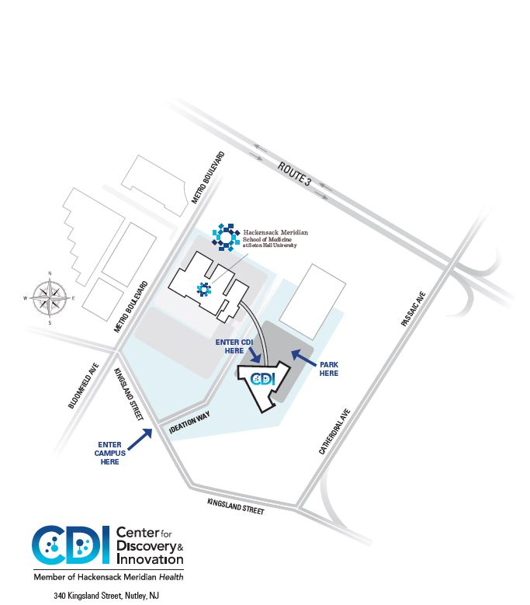

**Exhibitors**



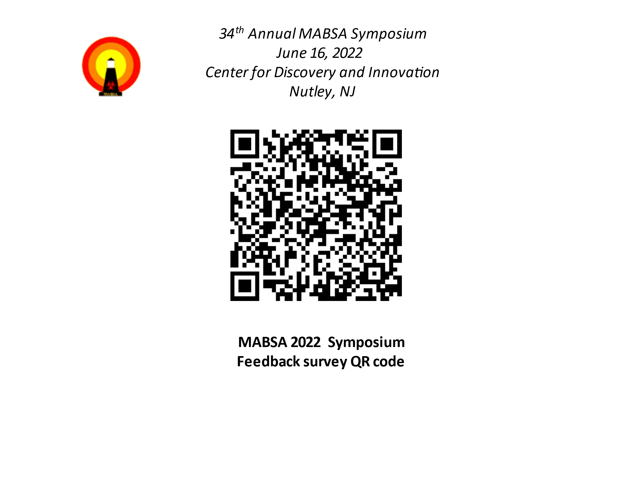

<https://www.surveymonkey.com/r/MABSA2022SYMP>

**If you wish to receive the certificate of attendance, please provide your name and email address when completing the survey!**